HONG KONG INSTITUTE OF VOCATIONAL EDUCATION
Lab 7 – Regression & Clustering

Lesson Intended Learning Outcome:
- Explain the basic concepts of Regression & Clustering;
- Implement the major Regression & Clustering tasks; and
- Implement the basic tasks of Regression & Clustering.

TASK:

I. Linear Regression
1120
- Consider the following coding:
import numpy as np
import matplotlib.pyplot as plt
import sklearn # This imports the scikit-learn library
from sklearn.linear_model import LinearRegression
from sklearn.metrics import mean_squared_error

rng = np.random.RandomState(1)
arrX = 10 * rng.rand(50)
arrY = 3 * arrX - 5 + rng.randn(50)
model=LinearRegression(fit_intercept=True)
model.fit(arrX[:,np.newaxis], arrY)
xfit=np.linspace(0,10)
yfit=model.predict(xfit[:, np.newaxis])
plt.plot(xfit,yfit, color="black")
plt.plot(arrX,arrY, 'o')
# The following will draw as many line segments as there are columns in matrices x and y
plt.plot(np.vstack([arrX,arrX]), np.vstack([arrY, model.predict(arrX[:, np.newaxis])]), color="red");

print("Parameters:", model.coef_, model.intercept_)
print("Coefficient:", model.coef_[0])
print("Intercept:", model.intercept_)

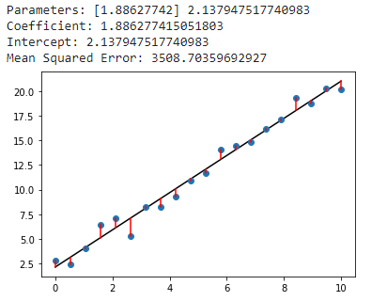
Sample Output:

print("Mean Squared Error:",mean_squared_error([arrY[10]], model.predict([[arrX[10]]])))

  - Try to find the Mean Squared Error when the value is under arrY[10]
  - Try to estimate the equation between arrX and arrY

- Write a Linear Regression model to predict the insurance charges with different BMI value with given “insurnaceBMI.csv”.
  - Create a Linear Regression model
  - Show the Parameters from Part (a)
  - Show the Coefficient from Part (a)
  - Show the Intercept from Part (a)
  - Show the predict insurance charge when BMI = 50 from Part (a)
  - Plot the graph from Part (a) with a regression line

Parameters: [393.8730308] 1192.9372089611497
Coefficient: 393.87303079739524
Intercept: 1192.9372089611497
BMI: 50
predict insurance charges: [20886.58874883]

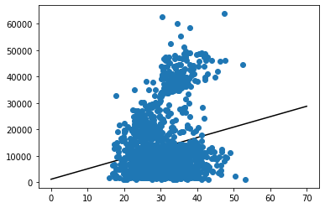

II. Clustering

Consider the following coding:
import numpy as np
import matplotlib.pyplot as plt
%matplotlib inline
from sklearn.datasets import make_blobs
X,y = make_blobs(centers=4, n_samples=200, random_state=0, cluster_std=0.7)
print(X[:10],y[:10])
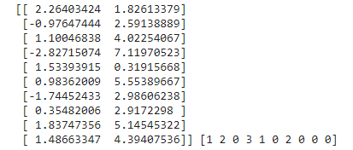

plt.scatter(X[:,0],X[:,1]);

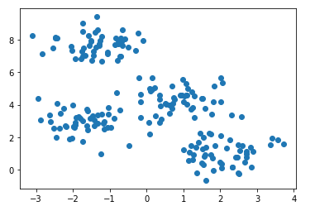

from sklearn.cluster import KMeans
model = KMeans(4)
model.fit(X)
print(model.cluster_centers_)
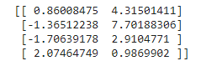

plt.scatter(X[:,0],X[:,1], c=model.labels_);
plt.scatter(model.cluster_centers_[:,0], model.cluster_centers_[:,1], s=100, color="red"); # Show the centres

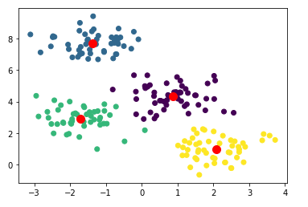

- Given the “InsuranceBMI.csv”
  - Create a K-means model with 3 clusters.
  - Show the Cluster Centers from Part (a)
  - Show the result clusters from Part (a) with a different color for each cluster using a scatter plot and three red points to locate the cluster centers.

*** End of Lab 7 ***

